Sulfamethoxazole / Trimethoprim Tablets, USP, 400 mg/80 mg CONSUMER-LEVEL RECALL CUSTOMER CARE/SPECIALTY/CLINICAL COUNSELING TALK TRACK

Background Information: On June 2, 2025, Amneal Pharmaceuticals issued a consumer-level recall of Sulfamethoxazole/Trimethoprim Tablets, USP, 400 mg/80 mg. This recall was issued as the tablets may exhibit black spots due to microbial contamination.

A list of the affected products and lot numbers is provided at the end of this document. The affected lots went into distribution on 12/4/2025.

Amneal Pharmaceuticals is instructing healthcare customers/pharmacies to notify consumers about this recall.

Customer Care Talk Track:

** Please ensure to disposition all recall calls to code “1116” **

Clinical Care Service/Specialty Pharmacy Talk Track

Clinical Care Technicians - Please ensure to disposition all recall calls to code “1456”
Clinical Care Pharmacists - Please ensure to disposition all recall calls to code “1408”

Q# | Question | Action | Answer
1 | I heard that there is an issue with my medicine, Sulfamethoxazole/ Trimethoprim Tablets, USP, 400 mg/80 mg. Can you give me more information? | Note: Check PeopleSafe to determine if the medication is from Mail or Specialty Pharmacy | If the medication was dispensed from… | Then say…
1 |  |  | Mail Order | - Yes, I can.  - Proceed to Q2
1 |  |  | Specialty | While in PeopleSafe, determine the phone number of the dispensing Specialty pharmacy and transfer the call.  A: Yes, I can. Please hold while I transfer you to your Specialty Pharmacy.

Customer Care/Specialty Talk Track Clinical Care Service/Specialty Pharmacy Talk Track
2 | Why is there a recall? What is wrong with the product? |  | On June 2, 2025, Amneal Pharmaceuticals issued a consumer-level recall of Sulfamethoxazole/Trimethoprim Tablets, USP, 400 mg/80 mg. This recall was issued because the tablets may show black spots due to microbial contamination.  For more information, call Amneal toll-free at 833-582-0812 Monday-Friday, 8:00 am to 5:00 pm, EST or email sulfamethoxazole-trimethoprim-recall@amneal.com. You may also call the United States Food and Drug Administration (FDA) toll-free at 1-888-INFO-FDA (1-888-463-6332) or visit www.fda.gov.
3 | May I return the rest of the Sulfamethoxazole/ Trimethoprim Tablets, USP, 400 mg/80 mg that I have? | Determine if the patient is affected by this recall | First, let’s determine if you are affected by this recall:
3 |  | Determine if the patient is affected by this recall | If the product was dispensed in… |  | Then say...
3 |  | Determine if the patient is affected by this recall | Pharmacy Bottle |  | CVS Caremark® Mail Service Pharmacy/Specialty Pharmacy will send you replacement product and a postage-paid envelope to return the affected product. If you received any recalled product from your retail pharmacy, please contact the pharmacy that filled your prescription for more information including return instructions.  Please note: If the member received recalled product, please submit a damaged bottle reship order and indicate the amount of replacement product to be sent. Please make sure to request call tag.
4 | Should I stop using my Sulfamethoxazole/ Trimethoprim Tablets, USP, 400 mg/80 mg? |  | If the medication was dispensed from… |  | Then say…
4 |  |  | Mail Order |  | Customer Care:  Please hold while I transfer you to one of our Clinical Counseling Clinicians.  Clinical Care Service:  Amneal advises that consumer should not use Sulfamethoxazole/Trimethoprim Tablets, USP, 400 mg/80 mg that is affected by this recall. Please call your doctor right away for advice if you might be using affected drug. Your doctor knows your medical history and can tell you what to do next. If you need a prescription for a different drug, please contact your doctor.
4 |  |  | Specialty |  | Customer Care:  Please hold while I transfer you to your Specialty Pharmacy.  Clinical Care Service:  Amneal advises that consumer should not use Sulfamethoxazole/Trimethoprim Tablets, USP, 400 mg/80 mg that is affected by this recall. Please call your health care professional right away for advice if you may be using affected product or if you do not know if you used affected drug. Your doctor is familiar with your medical history and can suggest the best treatment option for you.
5 | Will I receive credit for the product I return? |  | Your insurance will be credited for any affected product returned to us. We will replace the affected product with unaffected product. You will not be charged any additional copayments.

Affected products and lot numbers:

Product Name | NDC # | Affected
Sulfamethoxazole/Trimethoprim Tablets, USP, 400 mg/80  100 count bottle | 65162-0271-10 | AM241019 exp. 06/2027  AM241020 exp. 06/2027
Sulfamethoxazole/Trimethoprim Tablets, USP, 400 mg/80  500 count bottle | 65162-0271-50 | AM241019A exp. 06/2027

Additional Information:

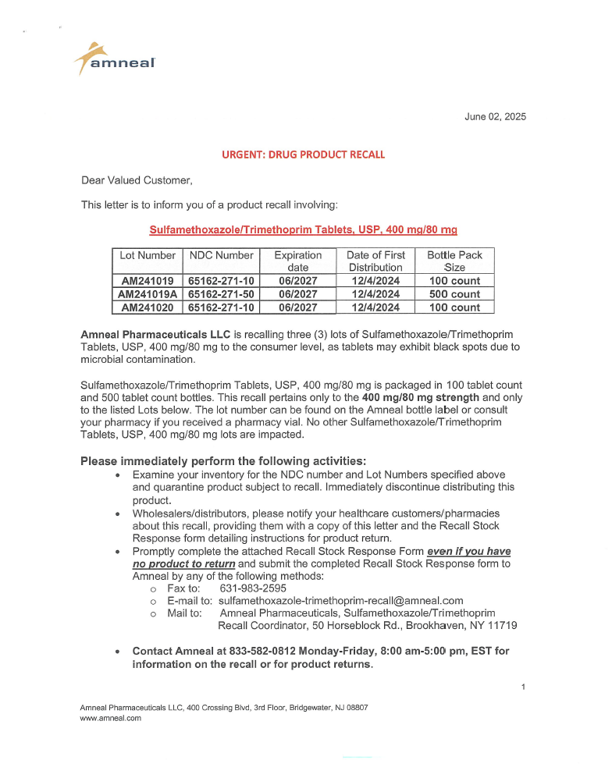

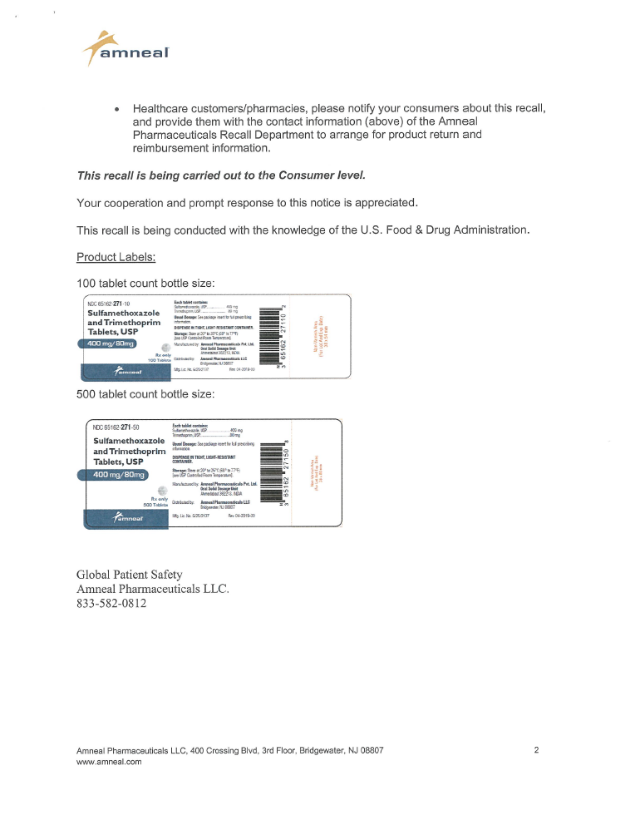

Press Release Details

Amneal Pharmaceuticals LLC issues a Nationwide Recall of Sulfamethoxazole Trimethoprim Tablets, USP, 400 mg/80 mg only, due to Microbial Contamination

June 3, 2025

FOR IMMEDIATE RELEASE – 06/02/2025 – Bridgewater, NJ, Amneal Pharmaceuticals LLC ("Amneal"), is recalling three lots of Sulfamethoxazole/Trimethoprim Tablets, USP, 400 mg/80 mg to the consumer level as the tablets may exhibit black spots on the tablet surface due to microbial contamination. The observance of black spots was reported in a product quality complaint.

Risk Statement: Oral products contaminated with Aspergillus may result in serious and life-threatening infections. The use of the defective product in patients with underlying immunosuppressive conditions increases the concern for serious infections. To date, Amneal has received no reports of adverse events, illnesses or injuries related to this recall.

The recalled product was distributed nationwide to wholesalers/distributors between the dates of 12/4/2024 to 5/15/2025 only.

The product is indicated for the treatment of urinary tract infections caused by susceptible strains of the following organisms: Escherichia Coli, Klebsiella species, Enterobacter species, Morganella morganii, Proteus mirabilis and Proteus vulgaris, acute otitis media in pediatric patients, acute exacerbations of chronic bronchitis due to susceptible strains of Streptococcus pneumoniae and enteritis caused by susceptible strains of Shigella flexneri and traveler's diarrhea in adults.

Sulfamethoxazole/Trimethoprim Tablets, USP, 400 mg/80 mg is packaged in 100 tablet count and 500 tablet count bottles. This recall pertains only to the 400 mg/80 mg strength and only to the listed lots below. The lot number can be found on the Amneal bottle label or consult your pharmacy if you received a pharmacy vial. No other Sulfamethoxazole/Trimethoprim Tablets, USP, 400 mg/80 mg lots are impacted.

Lot Number | NDC Number | Expiration  Date | Date of First  Distribution | Bottle Pack  Size
AM241019 | 65162-271-10 | 06/2027 | 12/4/2024 | 100 count
AM241019A | 65162-271-50 | 06/2027 | 12/4/2024 | 500 count
AM241020 | 65162-271-10 | 06/2027 | 12/4/2024 | 100 count

Amneal is notifying its customers by UPS and is arranging for return of all recalled products. Wholesalers/distributors are being asked to notify their customers of the recall and provide instructions to contact Amneal for the return of the recalled products to Amneal. Retailers are being asked to notify their customers and instruct consumers to contact Amneal directly for assistance with return of any recalled product and reimbursement information.

Individuals with questions regarding this recall can contact Amneal by:

Phone: 833-582-0812 Monday-Friday, 8:00 am-5:00 pm, EST

Fax: 631-983-2595

E-mail to: sulfamethoxazole-trimethoprim-recall@amneal.com

For Medical Inquiries or to report Adverse Events, or quality problems experienced with the use of this product, please contact Amneal Drug Safety by phone at 1-877-835-5472, Monday - Friday, 8:00 am – 6:00 pm, EST, or e-mail at DrugSafety@amneal.com.

Adverse reactions or quality problems experienced with the use of this product may be reported to the FDA's MedWatch Adverse Event Reporting program either online, by regular mail or by fax.
- Complete and submit the report Online: www.fda.gov/medwatch/report.htm¹
- Regular Mail or Fax: Download form www.fda.gov/MedWatch/getforms.htm² or call 1-800-332-1088 to request a reporting form, then complete and return to the address on the pre-addressed form, or submit by fax to 1-800-FDA-0178

This recall is being conducted with the knowledge of the U.S. Food and Drug Administration.

The following is a picture of the product label.

100 tablet count bottle size

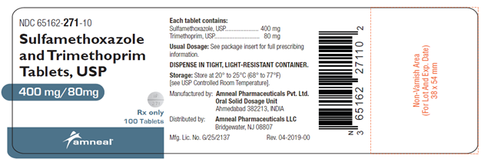

500 tablet count bottle size

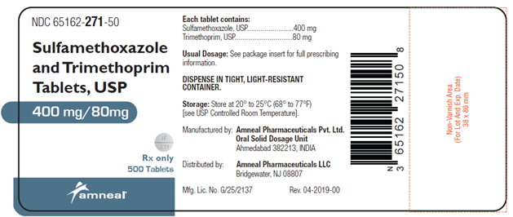

Top of the Document

Not to Be Reproduced or Disclosed to Others without Prior Written Approval
ELECTRONIC DATA = OFFICIAL VERSION / PAPER COPY = INFORMATIONAL ONLY

